Hello,
We need the following changes implemented:
- We need the index collum (that it is present in the Entry-exit register form)
  - 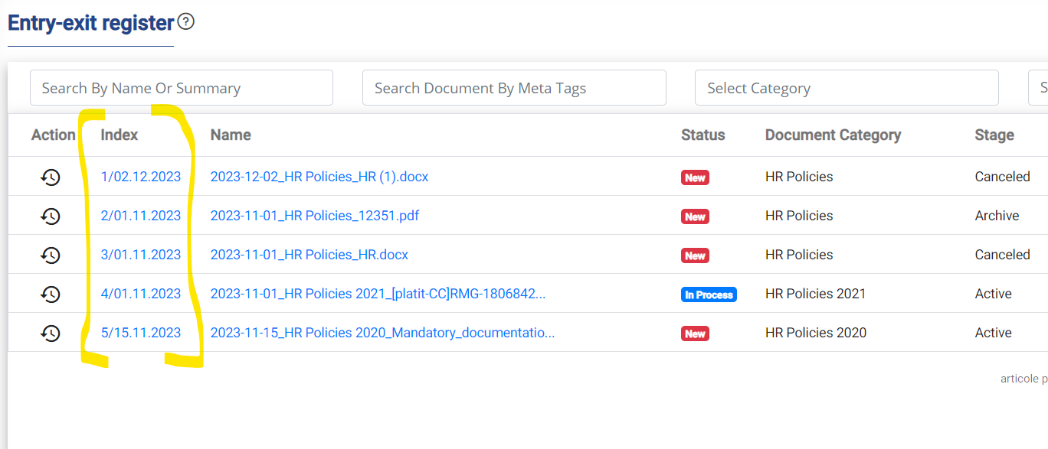
  - To be added in the Assigned Documents and All Documents forms between Action and Name collum(s).
  - 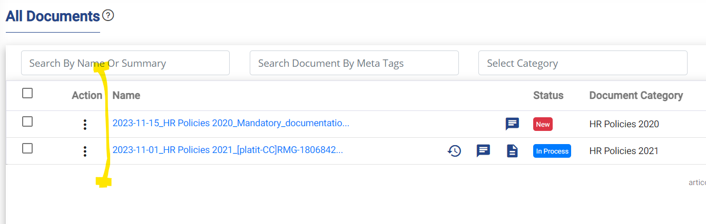
  - Also the Index label is ok in English but in Romanian should be Nr. Înrg.
- When adding a new document we need to implement a tooltip that will show the name of the category followed by the description. The client wants to add a longer description to each category (subcategory) and the tooltip will indicate to the users the purpose and usage of that selected category.
  - 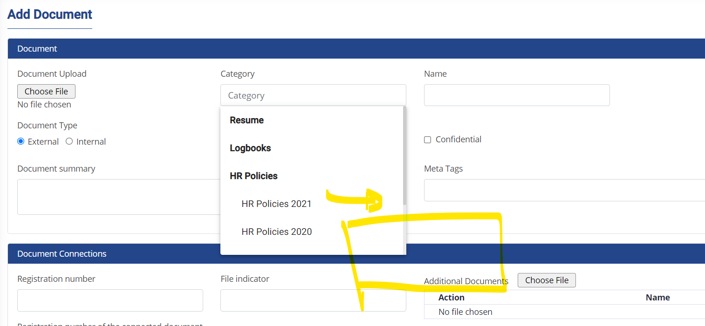
- When a document is Cancelled, the users will be prompted the Are you sure you want to Cancel … message – which is fine and need to add a second dialog that will ask for reason of cancellation. The English text will be “Reason for cancellation”, Romanian will be “Motivul anulării” and a text area below (that will be stored in the table associated with the document Remarks) and Ok button. I am thinking to store it in the Remarks in order to avoid an additional field just for this processing.
- If the client has more users (like 20) the users form needs to have implemented a sorting mechanism for the table headlines. This can be implemented for all the tables where this feature is missing (if any other is missing it).
- For additional documents we need to implement preview (open in new window) by adding the eye icon before download option.
  - 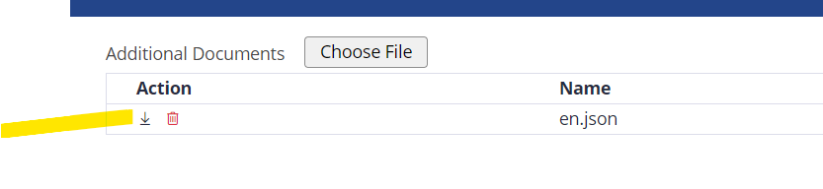
- For the Documents Audit Trail we need to implement an excel export feature of the results like in he Entry-exit register report. Also Clear button is Romanian is not clar – it is Resetare.
  - 
- We need to find a solution to preview Excel documents that are uploaded. This should work for a server hosted locally. This is actually one of the reasons that they will might not accept the project and we will not be paid… So even if it seems like a minor thing it is actually pretty important.
There are some additional (but very minor) changes that I will ask for on Monday – after they will decide what it I to be done with this field.
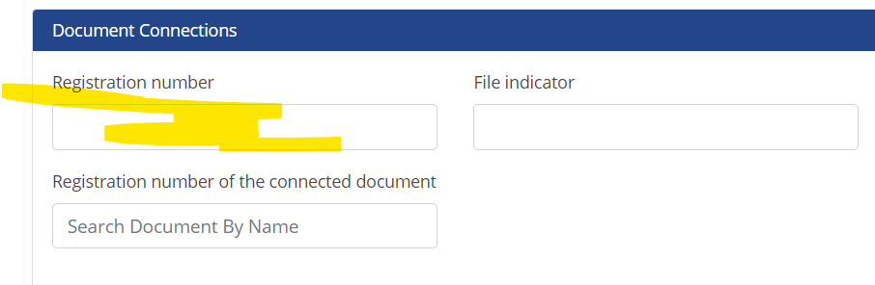
I want to provide them an updated version on 19 or 20 December.

